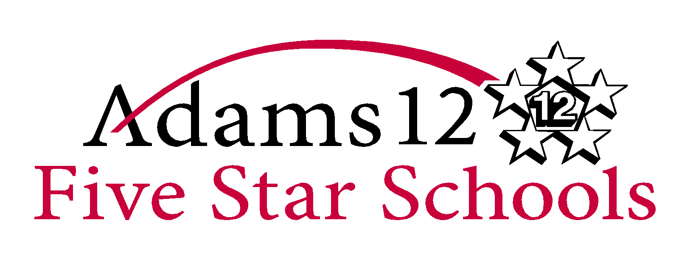
Northglenn High School
601 West 100th Place ● Northglenn, CO 80260
Office: (720) 972-4600 ● Fax: (720) 972-4739
http://www.northglennhs.adams12.org

School Year | 2017-2018 | Teacher Name | Sandy Sorensen
Office | Room 204 | Website | mssorensennghs.weebly.com
Phone | 720-972-2648 | Email Address | sandy.l.sorensen@adams12.org

Course Name |  | Environmental Science
Course Description |  | The goal of Environmental Science is to provide students with the scientific principles, concepts, and methodologies required to understand the interrelationships of the natural world, to identify and analyze environmental problems both natural and human-made, to evaluate the relative risks associated with these problems, and to examine alternative solutions for resolving and/or preventing them.
Unit of Study | Grade Level Expectations/Content Standards |  | Approx. Time Spent | Approx. Assessment
Earth Systems and Resources | - Introduction to Environmental Science (importance of environmental science and identify ways in which humans have altered the environment)  - Economics and Environmental Policies  - Earth Concepts: (earth's systems, sustainability, indicators and trends)  - HS-LS2-5, HS-ESS1-5, HS-ESS1-6, HS-ESS2-2, HS-ESS2-2 |  | 5 weeks | 09/30
Living World | - Analyze how matter and energy are connected  - Describe major biomes and analyze impacts of human activities on them.  - Ecosystem Structure: (Biological populations and communities; ecological niches; interactions among species; keystone species)  - Energy Flow: (Photosynthesis, cellular respiration, food webs, trophic levels, ecological pyramids)  - Natural Biogeochemical Cycles:(Carbon, nitrogen, and water)  - HS-LS1-1, HS-LS1-3, HS-LS1-4, HS-LS1-5HS-LS1-6, HS-LS1-7, HS-LS2-1, HS-LS2-3, HS-LS2-14, HS-LS2-5, HS-LS2-6, HS-LS3-1, HS-ESS3-3 |  | 6 weeks | 11/11
Population | - Human population size: (affected by birth, death, fertility, and migration rates)  - Analyze how the growth of the human population is impacting the condition of the environment  - Use of land: (Urban land development, Public and federal lands, Land conservation options)  - HS-LS2-6, HS-LS2-7, HS-ESS2-7, HS-ESS3-1, HS-ESS3-3, HS-ETS1-1, HS-ETS1-3 |  | 4 weeks | 12/15
Land and Water Use | - Feeding a growing population: (types of agriculture; Green Revolution; genetic engineering and crop production; irrigation)  - Controlling pests: (Types of pesticides; costs and benefits of pesticide use; environmental impact)  - HS-LS2-7, HS-ESS3-4, HS-ETS1-1, HS-ETS1-4 |  | 6 weeks | 01/06
Energy Use and Climate Change | - Energy Consumption: (History, energy crisis, Present global energy use, Future energy needs)  - Energy Conservation: (Energy efficiency)  - Fossil Fuel Resources and Use: (Formation of coal, oil, and natural gas; world reserves and global demand; environmental advantages/disadvantages of sources)  - Renewable Energy: (Solar energy; hydroelectric; nuclear; hydrogen fuel cells; biomass; wind energy; geothermal; environmental advantages/disadvantages)  - Climate Change: (Causes; impacts; possible solutions)  - HS-LS1-6, HS-LS2-6, HS-LS2-7, HS-LS2-8, HS-ESS2-2, HS-ESS2-4, HS-ESS2-6, HS-ESS2-7, HS-ESS3-1, HS-ESS3-2, HS-ESS3-4, HS-ESS3-5, HS-ESS3-6, HS-ETS1-1, HS-ETS1-3 |  | 7 weeks | 02/17
Pollution | - Air pollution: (Sources—causes and effects; heat islands, and indoor air pollution)  - Water pollution: (Sources, surface & groundwater issues; conservation, maintaining water quality)  - Hazardous chemicals in the environment: (Types of hazardous waste; treatment/disposal of hazardous waste; cleanup of contaminated sites; biomagnification)  - Solid waste: (Types; disposal; reduction)  - HS-LS2-7, HS-ESS3-4, HS-ESS3-26, HS-ETS1-1, HS-ETS1-3, HS-ETS1-4 |  | 6 weeks | 05/14

Grading Scale |  | Grade Percentages/Weights
A | 90-100 | Summative Assessments & Projects | 80%
B | 80-89 | Formative Assessments & Projects | 20%
C | 70-79 | *Weekly progress grades are posted at https://ic.adams12.org/campus/portal/adams12.isp
D | 60-69
F | 59 or below

General Expectations
- Grades are based upon the demonstration of proficiency on units associated with a standard given during each formative or summative assessment. Formative grades in addition to summative unit assessments will be used to holistically determine your grade.
- Summative: 80% Summative measures of achievement are taken when unit master is expected. (i.e., unit tests, culmination of a project, embedded assessments, etc.)
- Formative: 20% Formative assessments measure the scaffolding skills and/or content embedded in the unit. Formative assessments are taken frequently, after a student has practiced a skill or become familiar with content. Examples of formative assessments include but are not limited to exit tickets, paragraphs, oral check for understanding, warm-ups, stages in a large project, etc.
- Assessments will be graded based on teacher/district/state rubrics.
- On group projects, students will receive a grade for individual work and a group grade.
- Grades are based on achievement of Content Standards and Grade Level Expectations.
Class Expectations
All class information will be available on the class website: www.McClurgScience.com
Absences, Retakes & Late/Missing Work:
- Students will have the number of days absent plus one for all excused absences. For extended absences, students should make prior arrangements with the teacher.
- Students who have an excused absence for an exam may be required to take an alternative exam and/or take the exam the day they return if the exam. If the absence is unexcused, make-ups will be on case-to-case bases.
- Students who are absent (excused) for a lab will have one week to make up the lab and/or may be required to participate in an alternative activity. If the absence is unexcused, make-ups will be on case-to-case bases.
  - Lab grades are based on completion of pre-lab assessments, participation during lab, adherence to safety regulations, housekeeping, and the written assignment. Pre-labs should be done prior to coming to class. This will help ensure the safety of all who will be working in the lab. Any students with long hair should ALWAYS keep a tie in their backpacks for lab days/activities.
  - Failure to comply with behavior expectations can result in removal from the lab activities and a low lab grade. A safety contract will be sent home and filled out by the student as well as the parent/guardian. These documents will be kept on file and are needed before a student can participate in any lab.
- If the absence is unexcused, it is expected that the missing work is completed, but the student will not receive credit for the work, and will be deduced 10%.
- Retakes are at the discretion of the teacher. A student must demonstrate that they have done something to improve their score (ie. completed missing homework, come in for extra help) before a retake is given.
- Assessment retakes will only be allowed to be retaken one time and if it the original assessment scores is 70% or Lower.
- All corrected assessment answers will be given ½ for each corrected answer.
- Students will have until the end of a unit to turn in any missing/late work for the unit. These assignments will not be given full credit. The student must have a conversation with the teacher about how many points these assignments will be worth.
- Missing or incomplete assignments/assessments for this course: Superintendent policies 6280 homework & 6281 make-up work will be followed for this course.
Homework & Class Participation:
- Most days you will have time to begin the HW assignment and ask questions before leaving class for the day ☺. Homework will be due at the beginning of class unless otherwise stated. Some homework will be graded for accuracy; some for completion, and some will be non-graded practice assignments.
- Participation is everything! If I see that you are paying attention, trying your best, and getting involved in what we are doing, I will do everything I can to see that you succeed. Get involved every day and I can guarantee you will do well in my class. You will also earn participation points, so stay focused and follow instructions.
Technology and Cell Phones:
- We will use computers a lot in this course. Misuse of the computers (ie. Inappropriate sites, off-task, unapproved sites) may result in failing grades
- Copy-and-pasting computer text into your work is considered plagiarism and will be dealt with under the guidelines of school board policy.
- Cell Phones, laptops and tablets can be used with permission for research only!!! If you are caught misusing your cell phone, first offense results in me taking the phone for the remainder of the class period. The 2nd offense results in me taking the phone for the remainder of the day, 3rd offence results in the phone being turned into student relations and the 4rd offence requires parents or guardian to come to school during class hours and sign out for the phone.
- Technology is essential for learning and investigating. Please do not abuse this privilege
Tutoring:
- Tutoring is offered from during 4th and 7th periods, and arrangements need to be made ahead of time in order to ensure I will be available.
Notebook:
- To pass this course you will need to keep an organized notebook. This should include any handouts you get in class, lab notes, and daily lecture notes. KEEP EVERYTHING! All assessments are based on notes taken & classroom activities. Some, but not all, assessments are open notes. As you progress in your education and careers, the importance of taking good notes cannot be underestimated.
Student Expectations
- Be ON time IN dress code. This means sitting in your desk when the bell rings!
- Bring ALL materials to class EVERYDAY.
- Listen carefully and Follow ALL directions.
- Be respectful to EVERYONE at ALL times. Respect all people and property
- Be on time, ready to work, when bell rings and work for the entire class
- No food or drink in lab; all safety guidelines that pertain to an unique lab must be followed
- Individual music can only be listened to during individual work time
- Cell phones need to remain away unless they are being used for an academic purpose. The teacher can take a cell phone for the rest of the period if a student has been warned about using it. Excessive violation of this expectation will result in the phone being taken to Student Relations and a parent may have to come to school to retrieve the phone
- Do not ask to use the bathroom during a lecture, whole class discussion, or peer presentation
Materials/Supplies needed daily:
- Pencils with ERASERS and pens for work
- Blue & Black pens (no assignments or assessments will be accepted in other colors, and the student will be given a 0.)
- 2” three-ring binder or spiral notebook (only used for this class, no others)
- Loose-leaf college rule notebook paper (8.5” x 11”). Any work turned in for grading, needs to be on loose-leaf paper ONLY – No torn spiral pages. Paper turned in with spiral edges will receive a 0.

